Lesson 2-4c Homework Practice
Solve Multi–Step Equations and Their Solutions

Solve each equation. State if the equation has infinitely many, one or no solution.
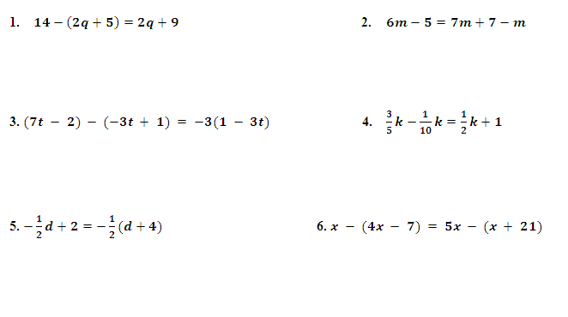
1. $14-\left(2q+5\right)=2q+9$ 2. $6m-5=7m+7-m$

3. $(7t - 2) - (-3t + 1) = -3(1 - 3t)$ 4. $\frac{3}{5}k-\frac{1}{10}k=\frac{1}{2}k+1$

5. $-\frac{1}{2}d+2=-\frac{1}{2}(d+4)$ 6. $x - (4x - 7) = 5x - (x + 21)$

REVIEW: Solve Proportions
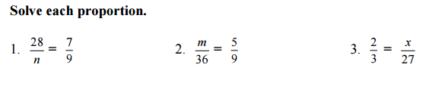
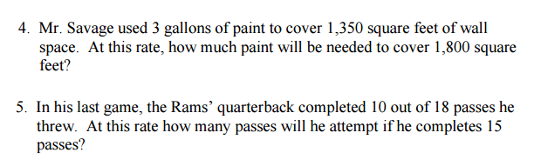

INEQUATLITIES REVIEW
