Lesson 11 Homework Practice
Solve Multi–Step Equations with Variables on Both Sides
Solve each equation. Check your solution.
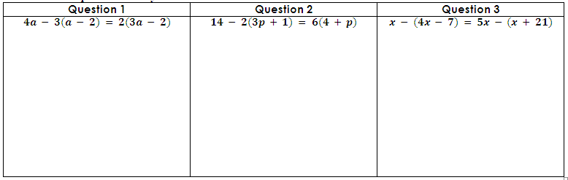  Question 1 | Question 2 | Question 3
$$4a - 3(a - 2) = 2(3a - 2)$$ | $$14 - 2(3p + 1) = 6(4 + p)$$ | $$x - (4x - 7) = 5x - (x + 21)$$
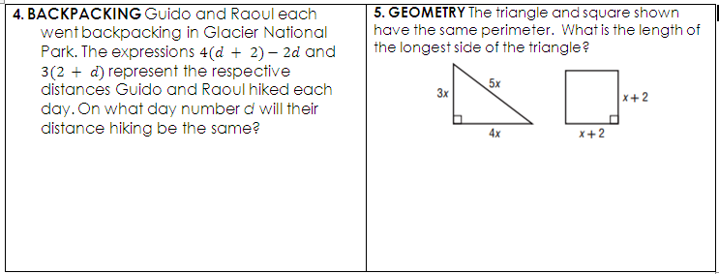
4. BACKPACKING Guido and Raoul each went backpacking in Glacier National Park. The expressions $4(d + 2)-2d$ and $3(2 + d)$represent the respective distances Guido and Raoul hiked each day. On what day number d will their distance hiking be the same? | 5. GEOMETRY The triangle and square shown have the same perimeter. What is the length of the longest side of the triangle?

