Lesson 11 Homework Practice
Compare Linear Functions

1. PORTRAITS Paolo’s Portraits charges $15 per photo with no sitting fee. The graph shows the fees for Clear Image Studio. Compare the functions by comparing their rates of change.
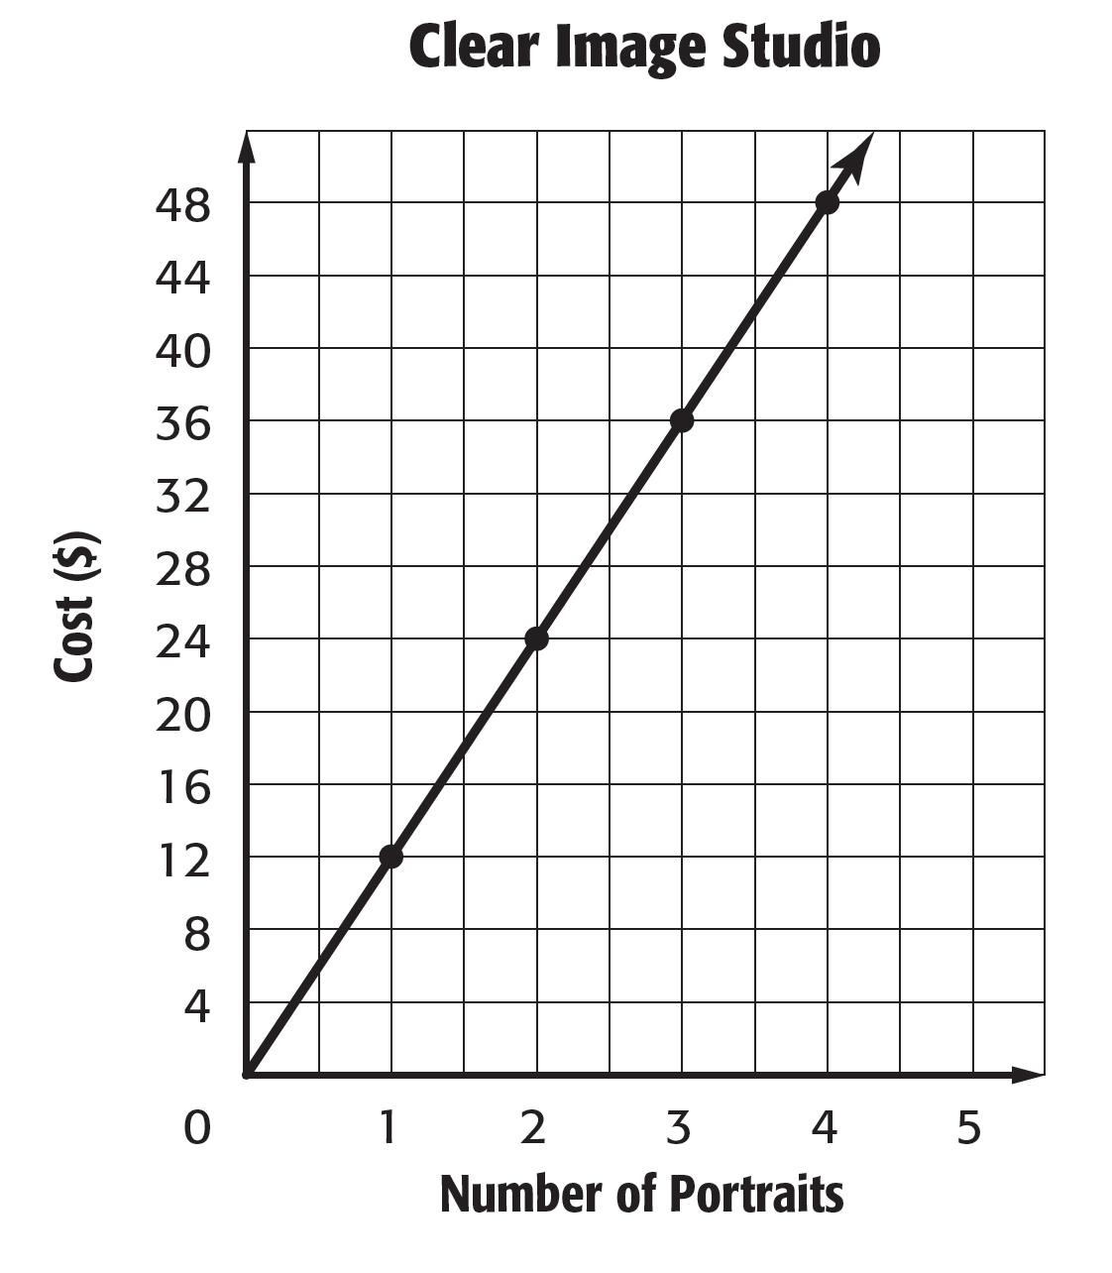

2. COMMISSION Joshua earns a salary plus a commission for every painting he sells. The equation y = 40x + 75, where y is the commission in dollars and x is the number of paintings, represents how much he earns. Martin’s commissions are shown in the table. Compare the functions by comparing their y-intercepts and rates of change.

Number of  Paintings Sold (x) | 1 | 2 | 3
Commission ($) (y) | 115 | 150 | 185

3. TOLL ROADS The table shows the cost for traveling on a toll road in Henderson. The graph shows the cost of traveling on a toll road in Clarkson. Compare the linear functions to determine which is a direct variation(proportional. Justify your response.
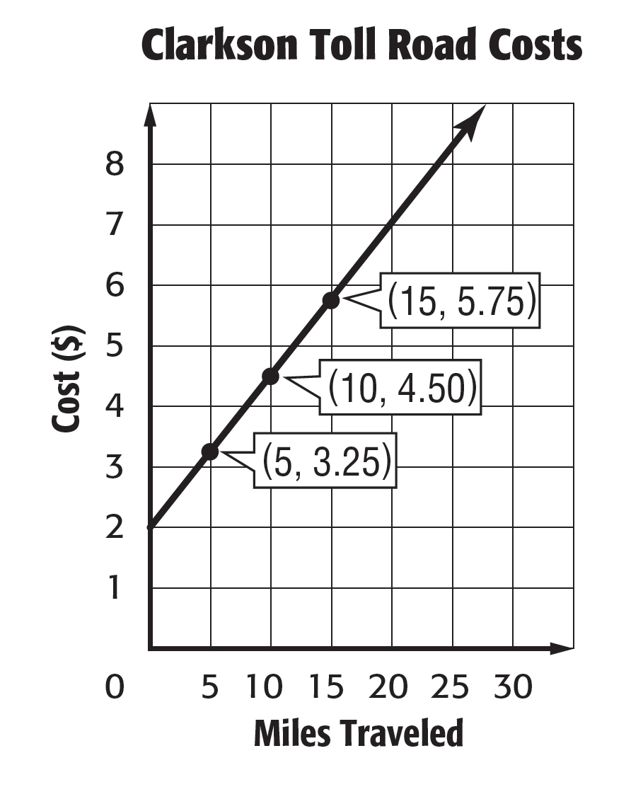
Henderson Toll Road Costs
Miles  Traveled | Cost ($)
10 | 3
20 | 6
30 | 9

