Lesson 1.6 Homework Practice
Multiply and Divide Scientific Notation
- Follow the steps in the sample problem carefully to simplify the following expressions
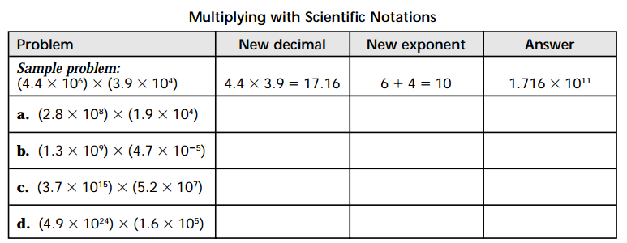

- Follow the step sin the sample problem carefully to simplify the following expressions
