Lesson 1.3b Homework Practice

Powers of Monomials
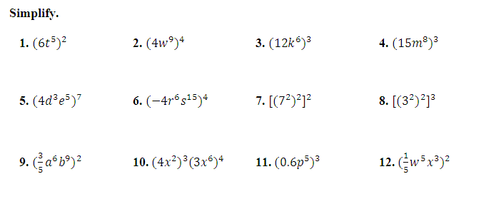
Simplify.

1. ${({6t}^{5})}^{2}$ 2. ${({4w}^{9})}^{4}$ 3. ${({12k}^{6})}^{3}$ 4. ${({15m}^{8})}^{3}$

5. ${({4d}^{3}e^{5})}^{7}$ 6. ${({-4r}^{6}s^{15})}^{4}$ 7. ${[{(7^{2})}^{2}]}^{2}$ 8. ${[{(3^{2})}^{2}]}^{3}$

9. ${(\frac{3}{5}a^{6}b^{9})}^{2}$ 10. ${({4x}^{2})}^{3}{({3x}^{6})}^{4}$ 11. ${({0.6p}^{5})}^{3}$ 12. ${(\frac{1}{5}w^{5}x^{3})}^{2}$

GEOMETRY Express the area of each square below as a monomial.

13. 14.
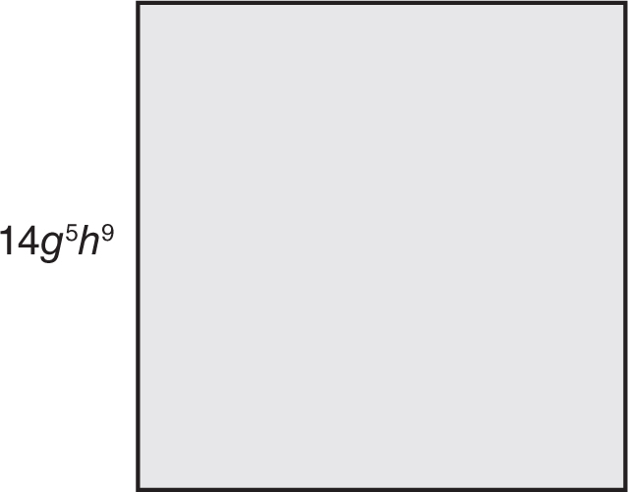

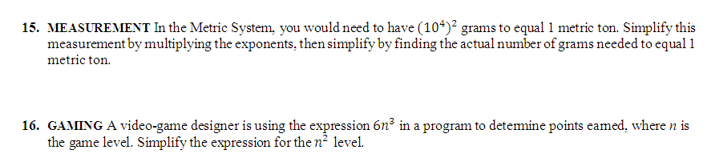
15. MEASUREMENT In the Metric System, you would need to have ${({10}^{4})}^{2}$ grams to equal 1 metric ton. Simplify this measurement by multiplying the exponents, then simplify by finding the actual number of grams needed to equal 1 metric ton.

16. GAMING A video-game designer is using the expression ${6n}^{3}$ in a program to determine points earned, where n is the game level. Simplify the expression for the $n^{2}$ level.

