SUM/PRODUCT OF REAL #’S HOMEWORK (1-5/1-6)
Question 1a: Multiple Choice | Question 1b: Show work/explain correct answer
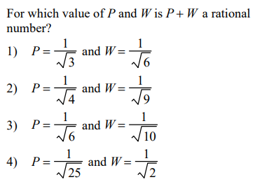
Question 2a: Multiple Choice | Question 2b: Show work/explain correct answer
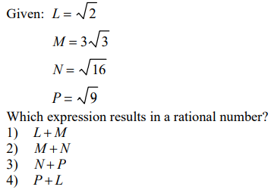

Question 2a: Multiple Choice | Question 2b: Create your own example for correct response/explain.
