NAME DATE____________CLASS______________ HW 1-1-0

Homework Practice 1-1-0: Contemplate then Calculate
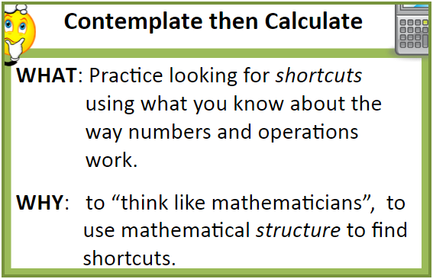 | 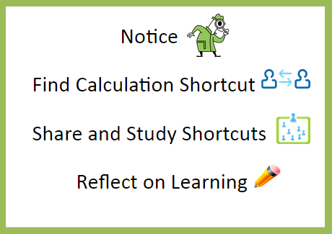 | Goal:  Make connections between the structure of a shape and ways to efficiently count the number of objects within the shape.

QUESTION 1: Tilted Square
NOTICE:  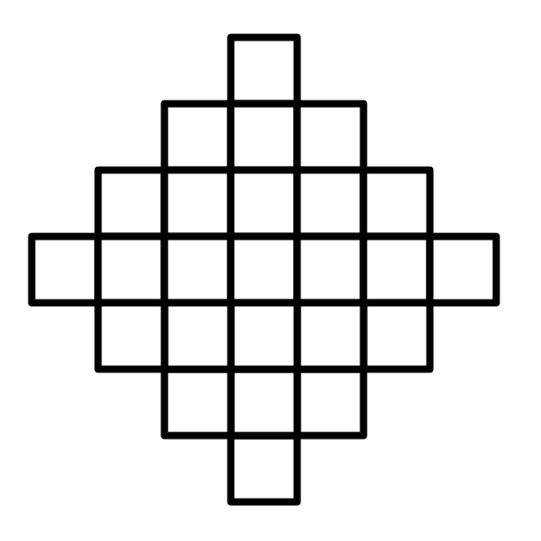 | NOTICE: Look at diagram for 3 seconds, what did you notice? Describe the shape
SHORTCUT 1:  Find the TOTAL # of small squares | SHORTCUT 1: What short cuts did you use to find the total # of squares? Show all work/Explain.
SHORTCUT 2:  Find the TOTAL # of small squares | SHORTCUT 2: What short cuts did you use to find the total # of squares? Show all work/Explain.
REFLECT:  Paying attention to … is helpful because…  You can find calculation shortcuts by… | REFLECT: Choose a sentence frame and write a reflection.
QUESTION 2: Looking at Triangles
NOTICE: |  | NOTICE: Look at diagram for 3 seconds, what did you notice?
SHORTCUT 1:  How many dots would the 6th triangle have? |  | SHORTCUT 1: What short cuts did you use to find how many dots are in the 6th triangle?
SHORTCUT 2:  How many dots would the 6th triangle have? |  | SHORTCUT 2: What short cuts did you use to find how many dots are in the 6th triangle?
REFLECT:  Paying attention to … is helpful because…  You can find calculation shortcuts by…  The next time I will…before I calculate because… |  | REFLECT: Choose a sentence frame and write a reflection.

