Lesson 1 Homework Practice

Classify Angles

Use the figure at the right to answer Exercises 1–4.
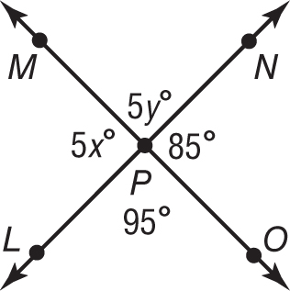
1. Name two angles that are vertical.

2. Name two angles that are adjacent.

3. Find the value of x.

4. Find the value of y.

Name each angle in four ways. Then classify the angle as acute, right, obtuse, or straight.

5. 6. 7.
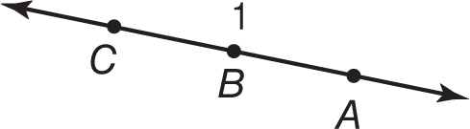
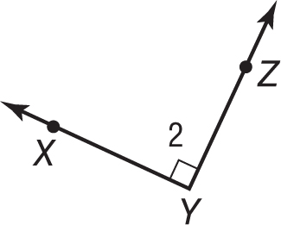
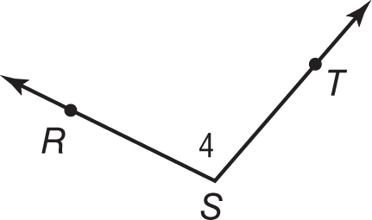

8. 9. 10.
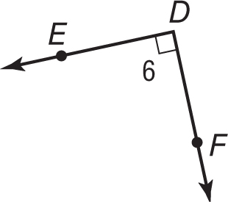
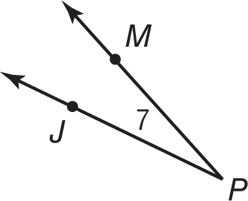
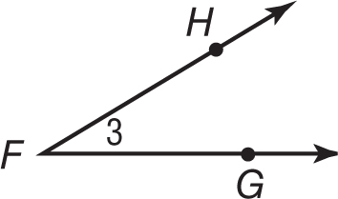

Use the figure at the right to name the following.
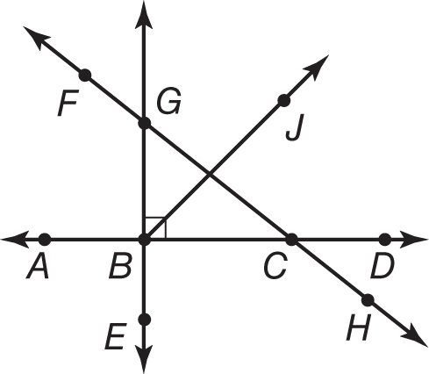
11. two acute angles

12. two straight angles

13. two right angles

14. two obtuse angles

