Integers Review Unit
Learning Target 4: Add Integers
Rules for Addition with Integers
Same Sign Integers | Opposite Sign Integers
Step 1: Ignore the signs | Step 1: Ignore the signs
Step 2: Add the numbers | Step 2: Subtract the numbers
Step 3: Keep the sign | Step 3: Keep the sign of the number with the larger absolute value

Example 1:
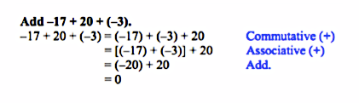
Example 2:
