Enrich
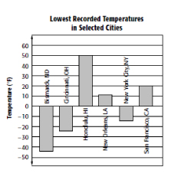

Graph with Integers

Statistical graphs that display temperatures, elevations, and similar data often involve negative quantities. On graphs like these, the scale usually will have a zero point and will include both positive and negative numbers.

For Exercises 1-6, use the bar graph to answer each question.
1. In which cities is the record low temperature greater than 0° Fahrenheit?

2. In which cities is the record low temperature less than 0° Fahrenheit?

3. In which city is the record low temperature about 25° Fahrenheit?

4. Estimate the record low temperature for New York City.

5. In which cities is the record low temperature less than twenty degrees from 0° Fahrenheit?

6. How many degrees are between the record low temperatures for Bismarck and Honolulu?

7. Make a bar graph for the data shown in the table below.

Altitude of Some California
Locations Relative to Sea Level
Location | Altitude (ft)
Alameda | 30
Brawley | −112
Calexico | 7
Death Valley | −282
El Centro | −39
Salton City | −230

