Lesson 1 Problem-Solving Practice

Integers and Graphing

SCUBA For Exercises 1–3, use the table below. The table shows the depths of scuba diving attractions on a certain dive tour.
Attractions | Depth (ft)
Coral reef | –22
Modern shipwreck | –98
Old shipwreck | –108
Cave | –16

1. Graph the integer representing the depth of the coral reef on a number line.  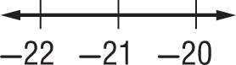 | 2. Hiromi took pictures of both shipwrecks. Graph the integers that represent the depths of the shipwrecks on a number line.
3. Sandra swam in the cave and around the coral reef. Graph the integer that represents the depth of the cave on a number line.  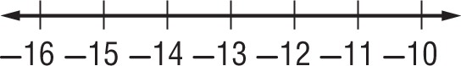 | 4. SCIENCE The liquid in Beaker A has a temperature of  –4°C. The liquid in Beaker B has a temperature of 2°C.  Graph the integers that represent the temperatures on a number line.  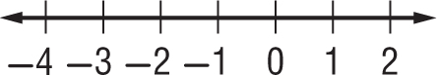
5. STEPS Catesby ran up 16 flights of stairs. Write an integer to represent this situation. | 6. CELL PHONE Nazir used more minutes on his cell phone than his plan allows. He now owes his parents $15. Write an integer to represent this debt.
7. CAVE The entrance of a cave is at an elevation of 14 meters. The lowest part of the cave is at an elevation of –86 meters. Write an integer to represent the elevation of the entrance to the cave. | 8. MONEY Larry lost 45 cents when it fell out of his jacket pocket while he was playing. Write an integer to represent this loss.

