**QUESTION #1**

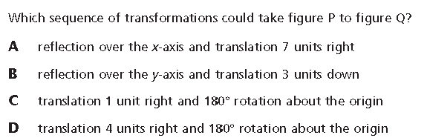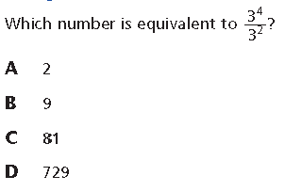

**QUESTION #2**

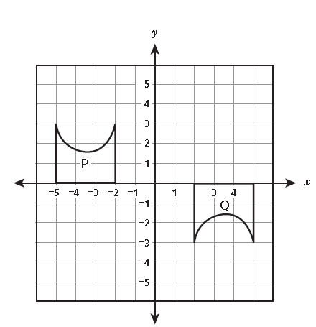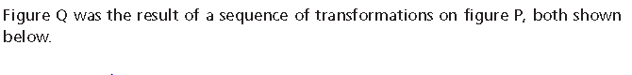

**QUESTION #3**

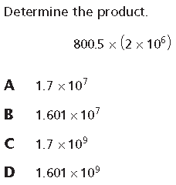

**QUESTION #4**

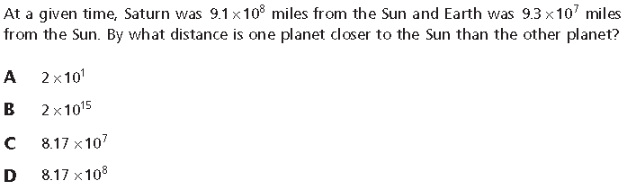

**QUESTION #5**

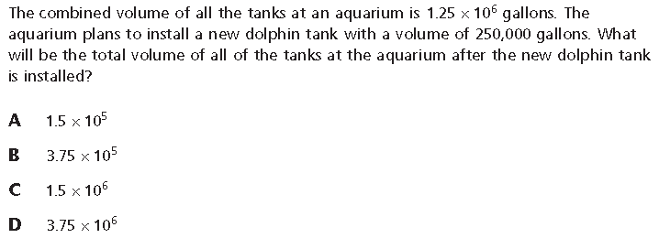

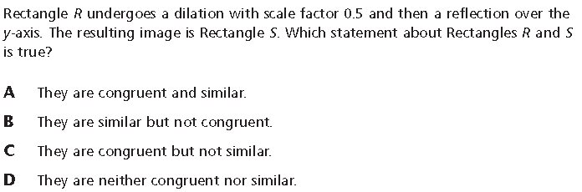

**QUESTION #7**

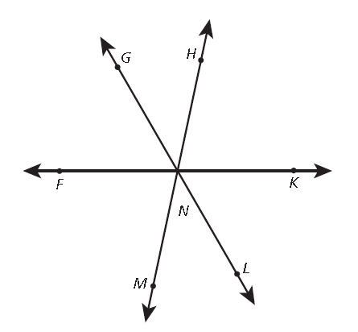

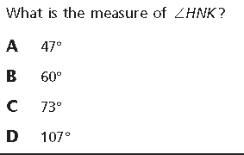

**QUESTION #8**



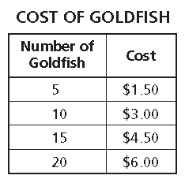

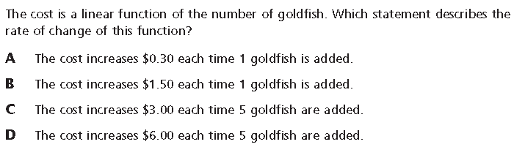

**QUESTION #9**

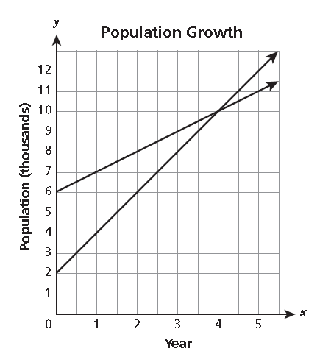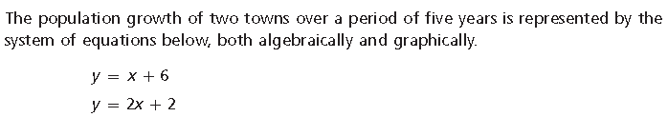

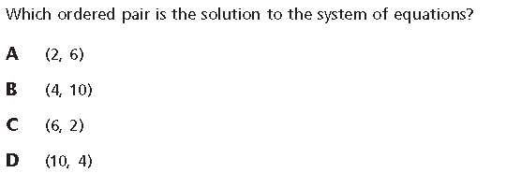

**QUESTION #10**

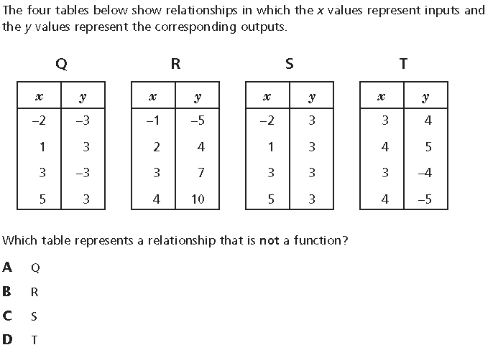

1. Which equation does **not** represent a linear function of x?

a. y = $-\frac{3}{4}x$ b. y= $\frac{x}{2}$ c. y =-3+2x d. y =3x2-2

1. A water tank is in the shape of a right circular cylinder with a height of 20 feet and a volume of 320 $π$. What is the diameter, in feet, of the water tank?

a. 16 b. 10 c. 8 d. 4

1. Which phrase best describes the graph of y = -2x +5?

a. a U-shaped curve that opens upward

b. a U-shaped curve that opens downward

c. a line that falls from left to right

d. a line that rises from left to right

1. What is the solution to the equation below?

**3(2x-4)+2(x+7)=6**

a. x = $\frac{3}{8}$ b. x= $\frac{1}{2}$ c. x= $\frac{4}{5}$ d. x= $\frac{11}{8}$

1. A line has a slope of $-\frac{1}{3}$ and passes through the origin. Which point lies on this line?

a. (-3, -1) b. (-1, 3) c. (3, -1) d. (3, 1)

1. Which equation is true for all of the values of x and y shown in the table?

|  |  |
| --- | --- |
| **x** | **y** |
| $$-\frac{1}{2}$$ | -2 |
| $$\frac{1}{2}$$ | 2 |
| 1 | 1 |

a. y= $\frac{1}{x}$ b. y= $\frac{4}{x}$ c. y =4x d. y=x

**17.** Calculate:

a. 4-32 b. 4-2 c. 44 d. 412

1. Which expression is equivalent to the fraction shown below?
$$\frac{2.4×{10}^{8}}{4.8×{10}^{-2}}$$

$.5×{10}^{-4}$

$.5×{10}^{6}$

$5×{10}^{11}$

$5×{10}^{9}$

2. Vertex D of rectangle ABCD is located at (3, -6). A dilation of ABCE will result in the image A’B’C’D’. If the dilation is centered at the origin and has a scale factor of 2, what is the coordinate of D’?
   1. (1, -2)
   2. (6, -12)
   3. (5, -4)
   4. (-6, 3)
3. A system of equations is shown below.

2x + 5y = 8

4x + 10y = 16

Which statement is about the ordered pair (-1 ,2 ) is true?

1. It is a solution to the first but not the second equation.
2. It is one of many solutions to the system.
3. It is not a solution to either equation.
4. It is the only solution in the system.

**SHORT ANSWER/CONSTRUCTED RESPONSE**

**QUESTION #21**

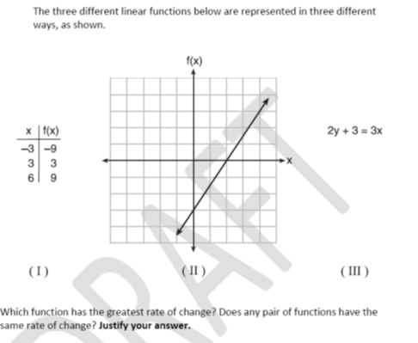

**QUESTION # 22**

Solve the system of equations graphically.



y =x

2y = -x + 8

**QUESTION #23**

If ST is reflected across the line y = x, what is the new coordinate point of T'? T’ ( )

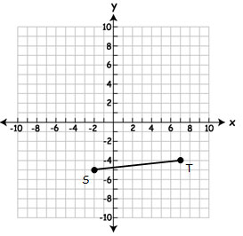

**QUESTION #24**

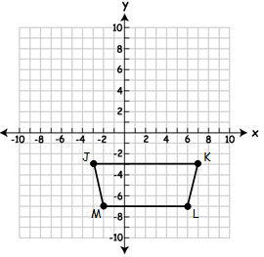 Rotate trapezoid JKLM clockwise 180 degrees. Label trapezoid J’K’L’M’. What is the coordinate of J’ ( , )?

MULTIPLE CHOICE

**QUESTION #25**

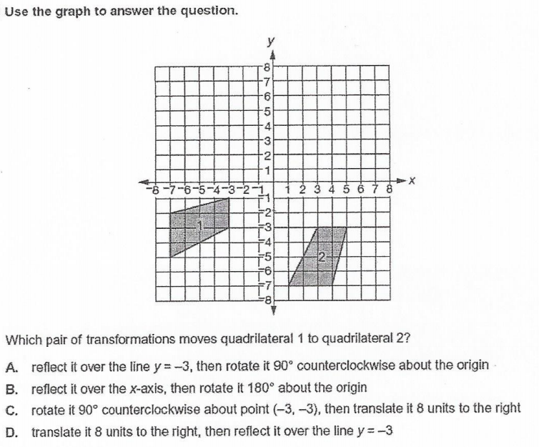

**QUESTION #26**

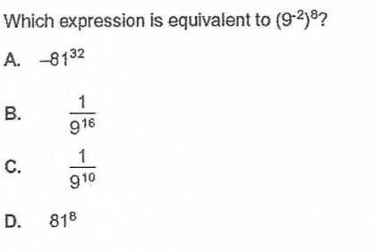

**QUESTION #27**

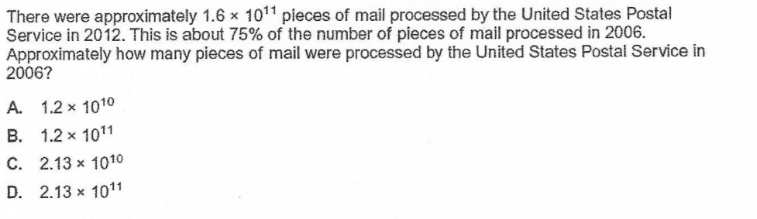

**QUESTION #28**

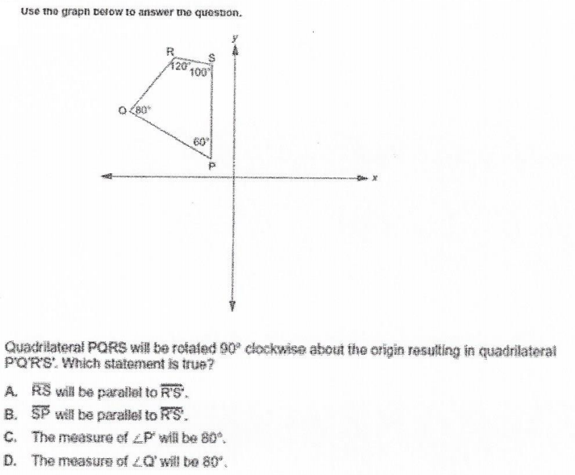

**QUESTION #29**

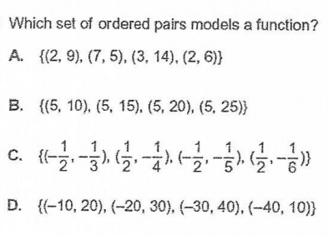

**QUESTION #30**

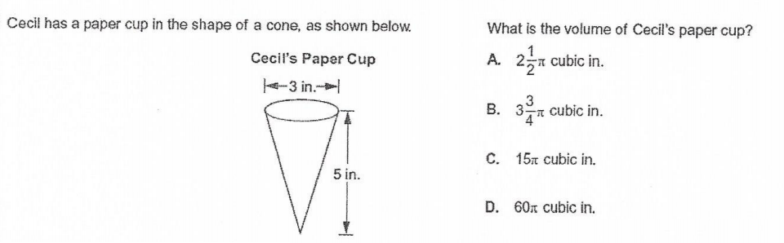

**QUESTION #31**

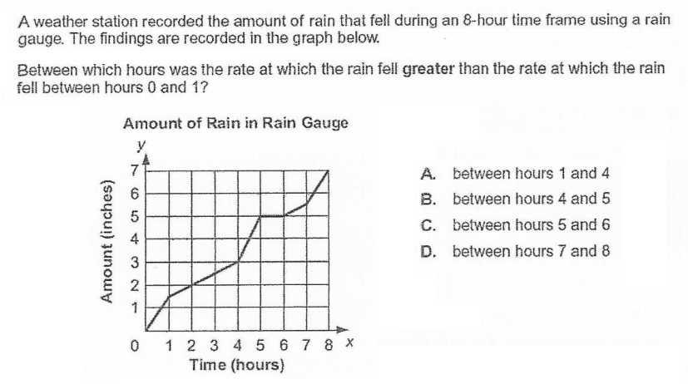

**QUESTION #32**

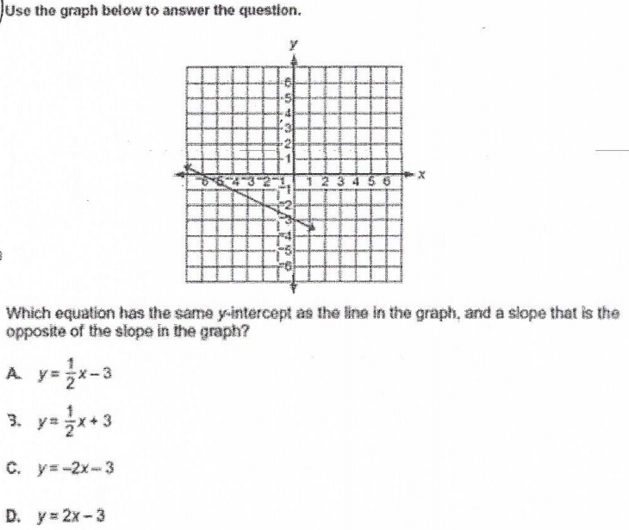

**QUESTION #33**

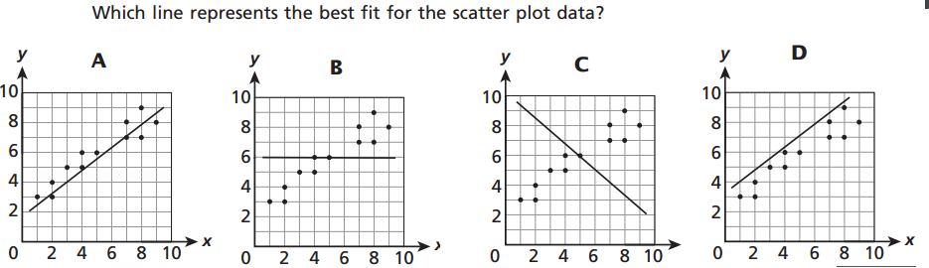

**QUESTION #34**



**QUESTION #35**

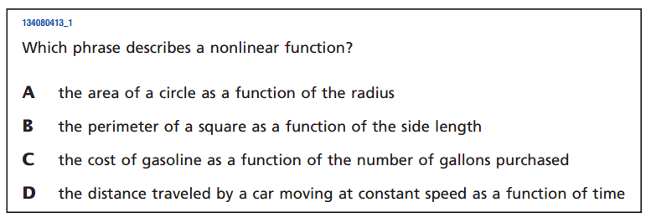

**QUESTION #36**

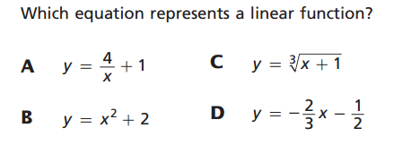

**QUESTION #37**

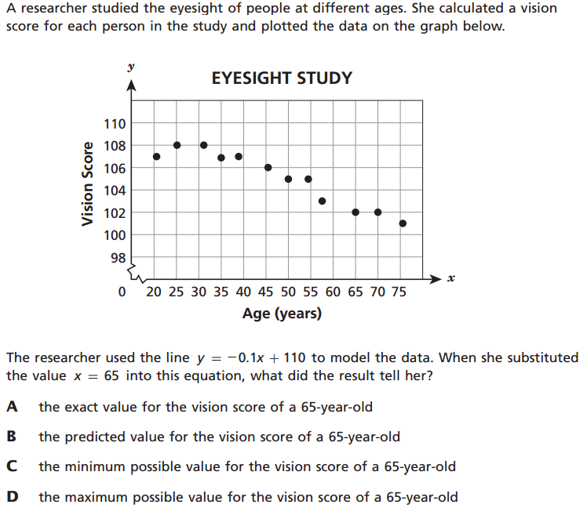

**QUESTION #38 – Which graph represents a function**

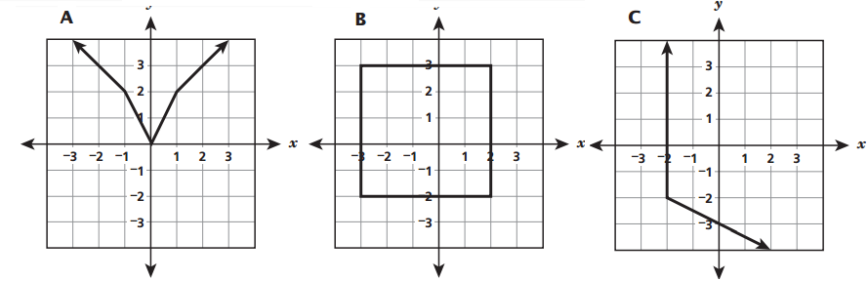

**QUESTION #39**

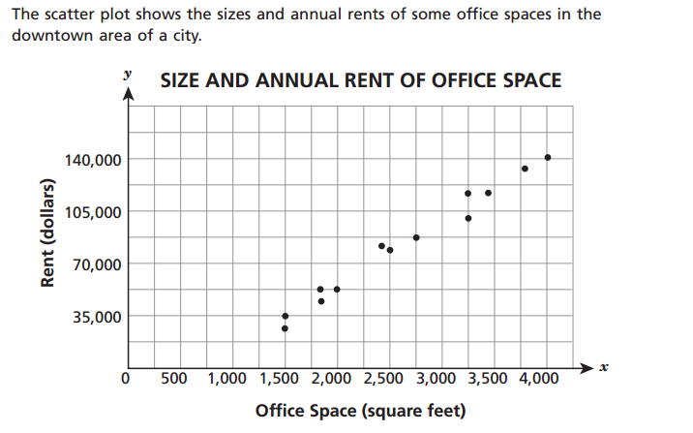

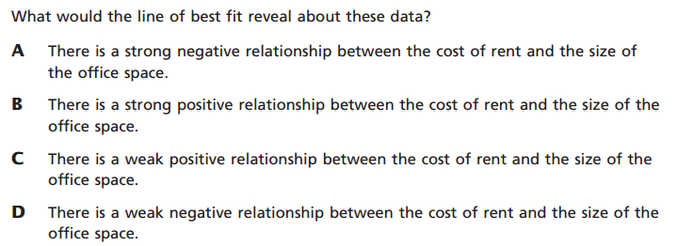

**QUESTION #40**

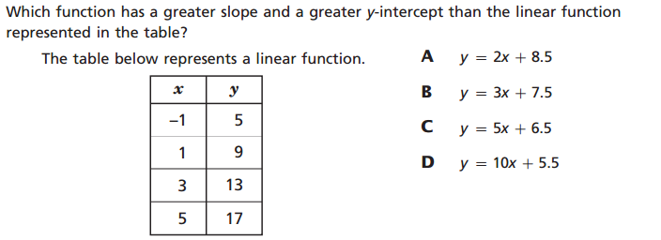

**QUESTION #41**

