**Exponents Review Sheet with Answers**

Practice and Check your answers when you are done.. If you are struggling see help on bottom of page

**Write the letter for the correct answer in the blank at the right of each question.**

**1.** What is the value of the expression (−4)3?

**6.** What is 3.471 × 10–5 written in standard form?

9*x*8*y*4

**7.**

**9.**

**8.**

**6.**

**I.** 0.0001

**G.**

**F.** −105

**3.** Using exponents, what is the simplified form of the expression (−3*x*4*y*2)2?

**2.** Using exponents, what is the simplified form of the expression ?

**5.**

**5.** The Statue of Liberty weighs 450,000 pounds. What is this number written in scientific notation?

**A.** 4.5 × 10–5 **C.** 4.5 × 104

**B.** 4.5 × 10–4 **D.** 4.5 × 105

**I.** 2*x*3

**4.**

**H.** 10–5

**4.** How is the expression 10−5 written using a positive exponent?

**D.**

**3.**

**C.** –9*x*8*y*4

**B.** 6*x*6*y*4

**A.** –6*x*6*y*4

**F.**

**2.**

**H.** 6*x*3

**G.** 63

23

**D.** 64

**C.** 12

**B.** –12

**A.** –64

**1.**

SCORE

PERIOD

NAME DATE

**A**

**I**

**C**

**G**

**D**



**D**

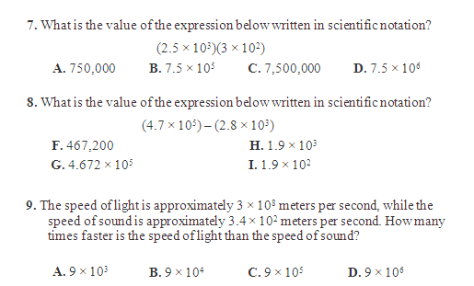

**B**

**B**

**C**

**G**

**10.** The top speed of a cheetah is approximately 1.2 × 102 kilometers per hour, while the speed of the fastest human is approximately 4 × 101 kilometers per hour. How many times faster is the top speed of a cheetah than the speed of a human?

Which statement is true?

**A**

1. The cheetah is 3 times fasters than the human
2. The cheetah is 30 times faster than the human
3. The human is 3 times faster than the cheetah
4. The human is 30 times faster than the cheetah

**10.**

SCORE

PERIOD

NAME DATE

**18**

THINGS TO REMEMBER

|  |  |  |
| --- | --- | --- |
| **Laws of Exponents**  Product law   1. Keep the base the same 2. Add the exponents   Quotient Law   1. Keep the base the same 2. Subtract the exponents   Power to a Power   1. Keep the base the same 2. Multiply the exponents | **Multiply Monomials**   1. Multiply Coefficients 2. Keep the base (variable) the same 3. Add Exponents   **Divide Monomials**   1. Divide Coefficients 2. Keep the base (variable) the same 3. Subtract the exponents | **Negative Exponents**   1. Take the reciprocal 2. Make the exponents positive   **Zero Exponents**  Anything to the zero power is 1 |
| **Add /Subtract Scientific Notation**   1. Put the #’s in standard form 2. Add/subtract 3. Put the answer in scientific notation | **Multiply #’s in Scientific Notation**   1. Multiply decimals 2. Keep the 10 the same 3. Add exponents 4. Make sure answer is in scientific notation   *lose a decimal, gain an exponent  *gain a decimal, lose an exponent | **Divide #’s in Scientific Notation**   1. Divide decimals 2. Keep the 10 the same 3. Subtract exponents 4. Make sure answer is in scientific notation   *lose a decimal, gain an exponent  *gain a decimal, lose an exponent |
| **Addition Word Problems**   * Combined * Altogether * increased * Sum   **Subtraction Word Problems**   * Decreased * Difference * How many more * how MUCH greater   longer  wider  more | **Unit Rate Words**   * Per day * Each day * Every day * A day * One day * daily   **Multiplication Word Problems**   * Unit rate is GIVEN * Find the area or volume * Product   **Division Word Problems**   * FIND the unit rate * How many TIMES greater | **Place Value**  Ten Thousandths .0001  Thousandths .001  Hundredths .01  Tenths .1  Ones 1  Tens 10  Hundreds 100  Thousands 1,000  Ten Thousand 10,000  Hundred thousand 100,000  Millions 1,000,000  Billions 1,000,000,000  Trillions 1,000,000,000,000 |