Homework Practice

Dilations

Find the coordinates of the vertices of each figure after a dilation with the given scale factor k. Then graph the original image and the dilation.

1. S(–2, 1), U(0, 1), N(–1, –1); k = 4 2. M(–3, 1), A(1, 3), T(2, –2), H(–4, –2); k $=\frac{1}{2}$
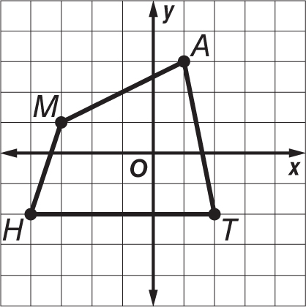
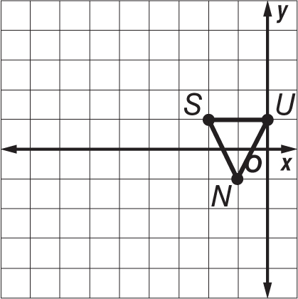

3. F(–2, 1), U(–1, 2), N(3, 1); k = 2 4. P(–4, 2), L(2, 4), A(2, –4), Y(–4, –2); k $=\frac{1}{4}$
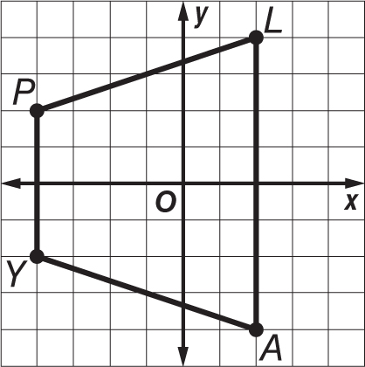
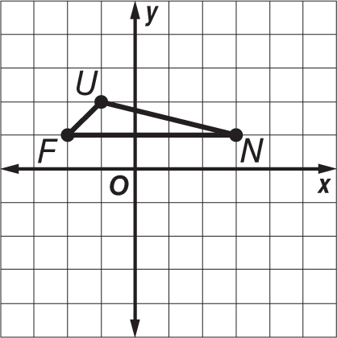

5. MAPS Rachel and her cousin, Lena, live in different cities that are about 100 miles apart. On a map, the two cities measure 5 inches apart. What is the scale factor used for the map?

6. GEOMETRY A square has vertices J(–1, 4), U(5, 4), M(5, –2), P(–1, –2). After a dilation, square JUMP has vertices J(–0.5, 2), U(2.5, 2), M(2.5, –1), P(–0.5, –1). What is the scale factor of the dilation?

7. LANDSCAPING A landscape designer has a drawing of a flower bed that measures 6 inches by 9 inches. The owner wants the actual flower bed to be 5 feet by 7.5 feet. What is the scale factor the designer must use to install the new flower bed?

