Construct Rotations Homework

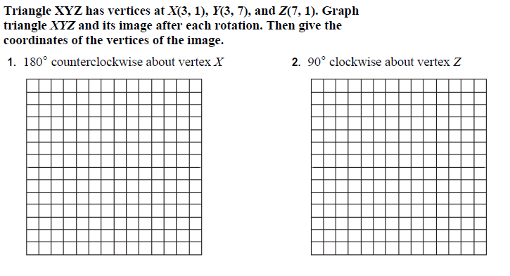

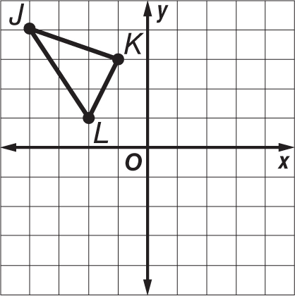
3. Triangle JKL has vertices J(-4, 4), K(-1, 3), and L(-2, 1). Graph the figure and its rotated image after a clockwise rotation of 90° about the origin. Then give the coordinates of the vertices for triangle J'K'L'.

4. Quadrilateral BCDE has vertices B(3, 6), C(6, 5), D(5, 2), and E(2, 3). Graph the figure and its rotated image after a counterclockwise rotation of 180° about the origin. Then give the coordinates of the vertices for quadrilateral BʹCʹDʹE'.
